Brack, Cris (from Linked In)

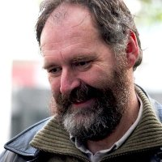

Bachelor of Science (Forestry) ANU 1978 – 1981. The University of British Columbia Doctor of Philosophy (PhD)1989 – 1991. Senior Inventory Officer State Forests NSW 1984 –1996. Associate professor at Australian National University 1994 – . Director of Research Waiariki Institute of Technology 2009 –2012 .

